YouTube Video Design
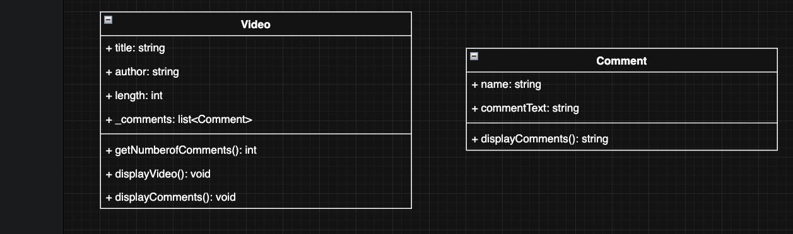

The program calls constructors for comments and creates a collection of them and then calls constructor for Video passing in the name, author, length, and the list of comments. This is repeated to create a list of video objects. Then the program will loop through the list of video objects. For each video object:
- The program will call the video object’s displayVideo method, which prints the title, author, length, and # of comments(via call to method getNumberofComments method) to the console.
- Next the display comments method is invoked
- The displayComments loops through the list of comments and calls the comments displayComment method which returns a string that is sent to the console

Online Ordering
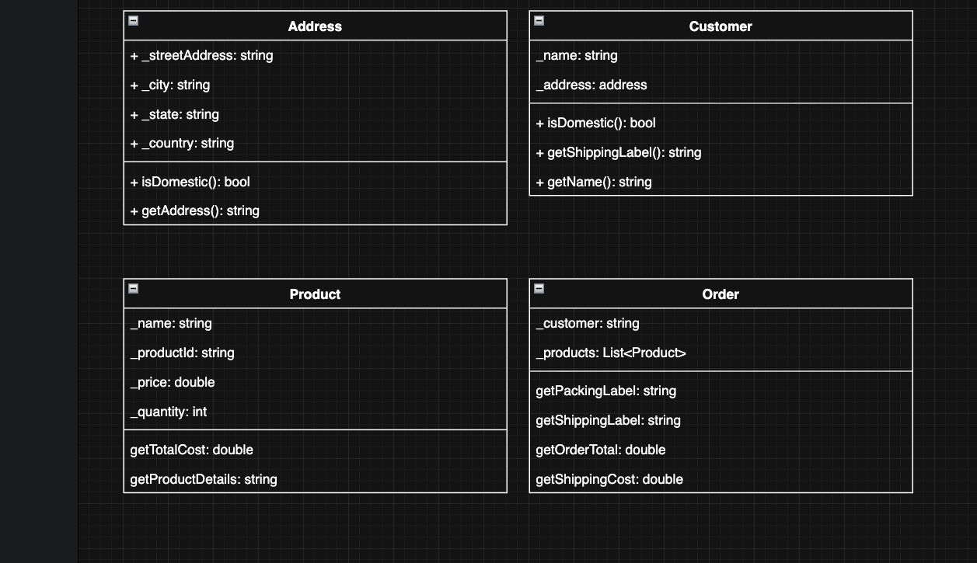

The program main line first creates the first address object by call the constructor with streetaddess, city, state, and county elements. Next the program creates the first customer object, again by calling a constructor with all the relevant data points.Next comes creation of three product objects created through constructor calls. These products are put into a list, then the order is created with the products list and customer objects passed into the constructor. From there getShippingLabel is used to return text to write to console. The order.getshippinglabel is just a pass through to the same method on the customer class.next getPackingLabel is call and this method loops through the product list andcalls the product.getProductDetails() method and returns them so the program and print them to the console. The program them makes calls to the getShippingCost and the getOrderTotal methods.This process is repeated for the second order.

